Assignment-6: AWS Deployment

Objective: Deploy a Flask backend and an Express frontend on AWS across three configurations — single EC2, separate EC2 instances, and Docker containers using ECR/ECS/VPC.
Note: If you are new to AWS, create an AWS account and take advantage of the one-year free tier, which provides access to a limited set of resources and services at no cost. For more details, refer to the official AWS Free Tier page: https://aws.amazon.com/free.
Tasks
- Deploy your Flask backend and Express frontend on a single Amazon EC2 instance.
- Deploy your Flask backend and Express frontend on separate EC2 instances.
- Deploy your Flask backend and Express frontend as Docker containers using AWS ECR, ECS, and VPC services.

Task1

Made a local Express frontend and flask backend application
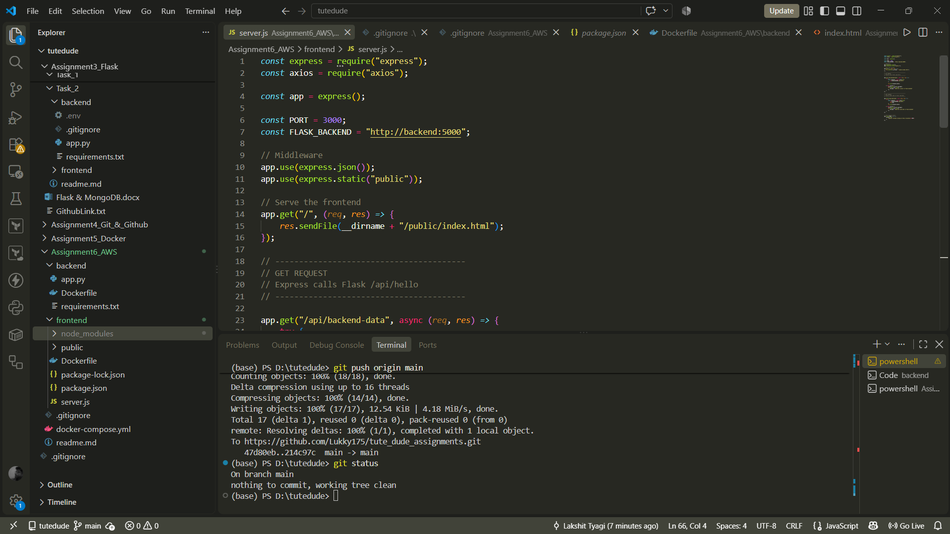

Pushed these changes on my tutedude repository https://github.com/Lukky175/tute_dude_assignments/tree/main/Assignment6_AWS

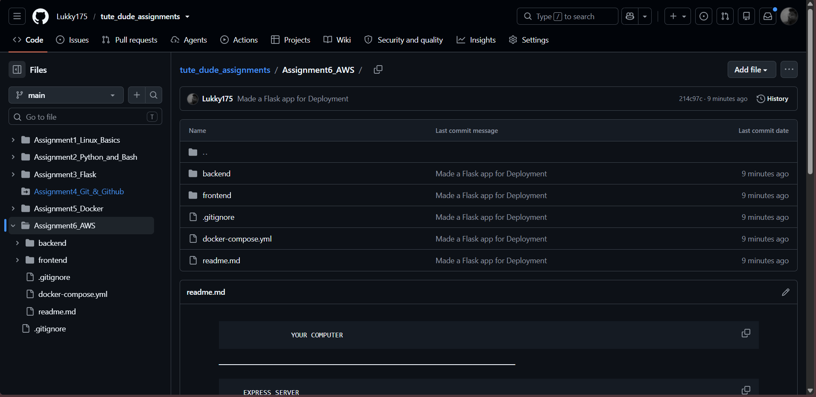

Launched an EC2 Instance with following configs
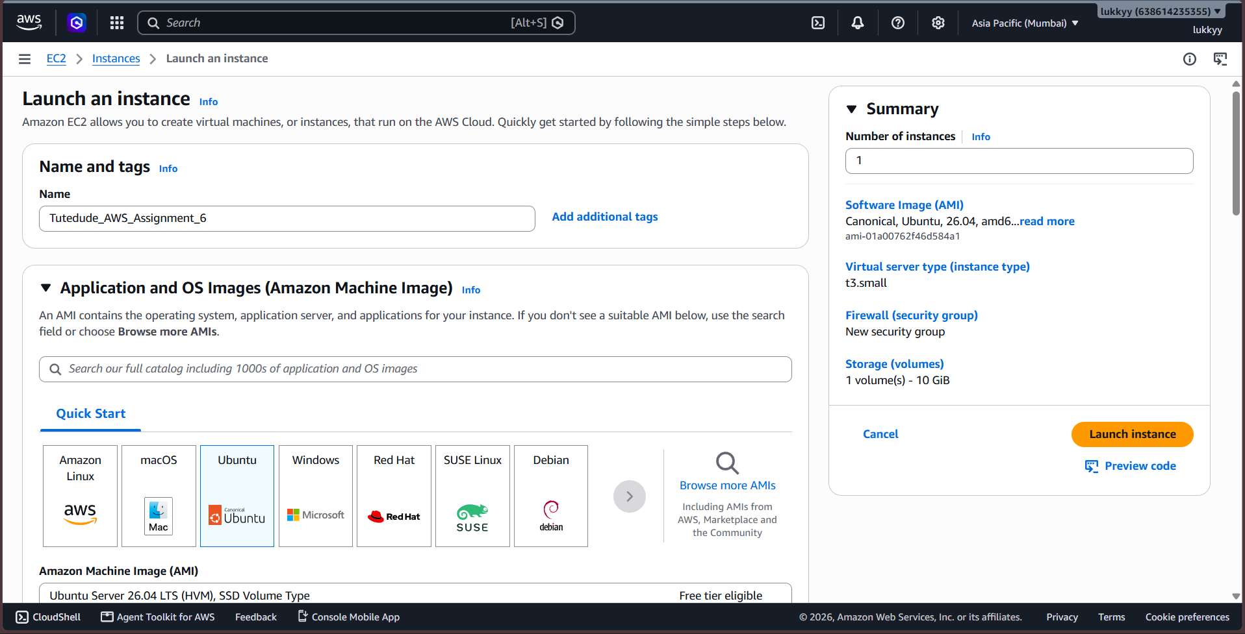

Public IP of EC2: 15.207.116.182
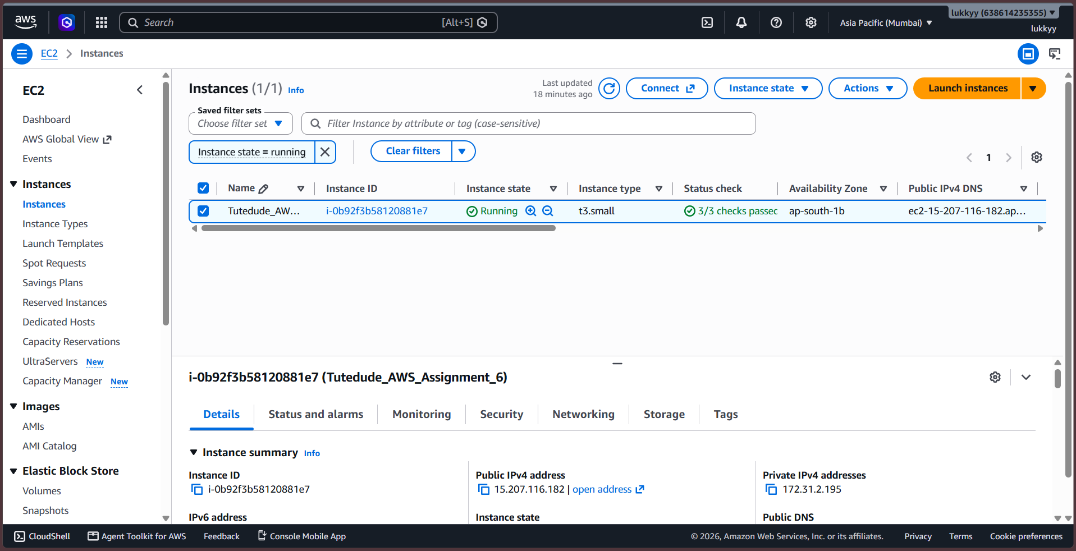

Did ssh in vscode powershell terminal
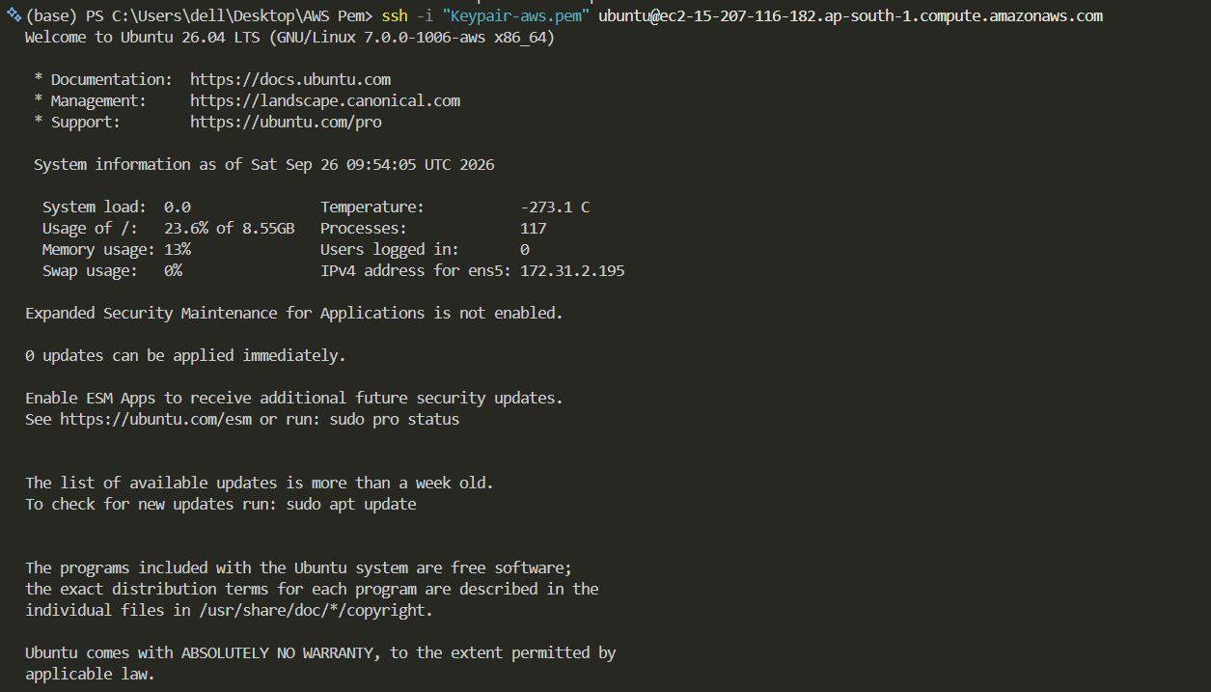

Cloned Repository in EC2
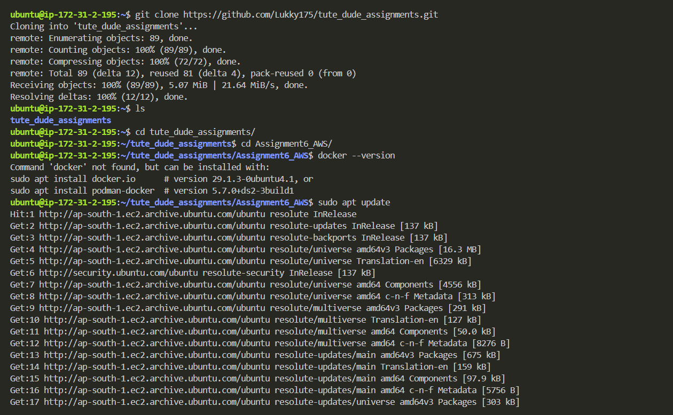

Did
sudo apt update
sudo apt install docker.io -y
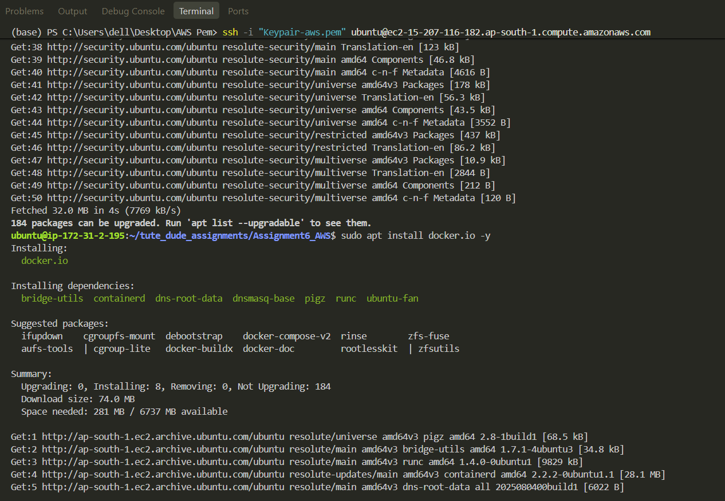

Ensure docker is running
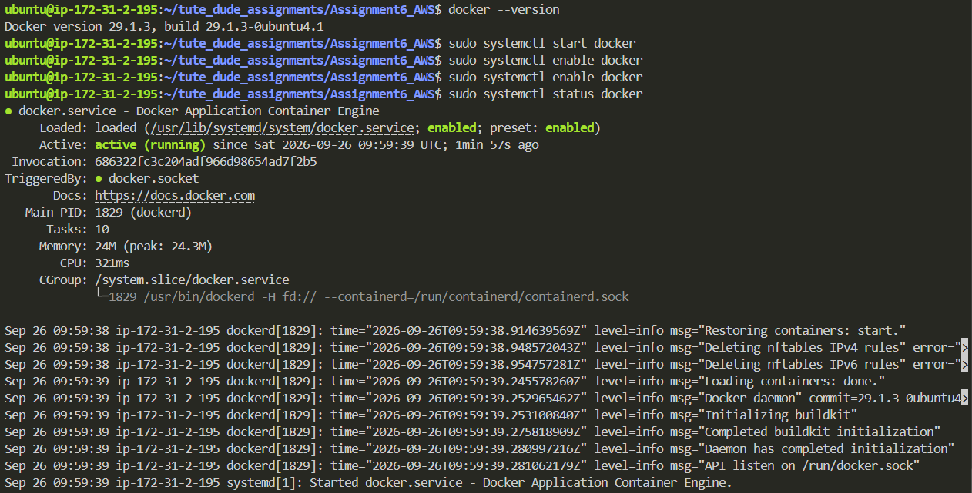
Installed Docker Compose
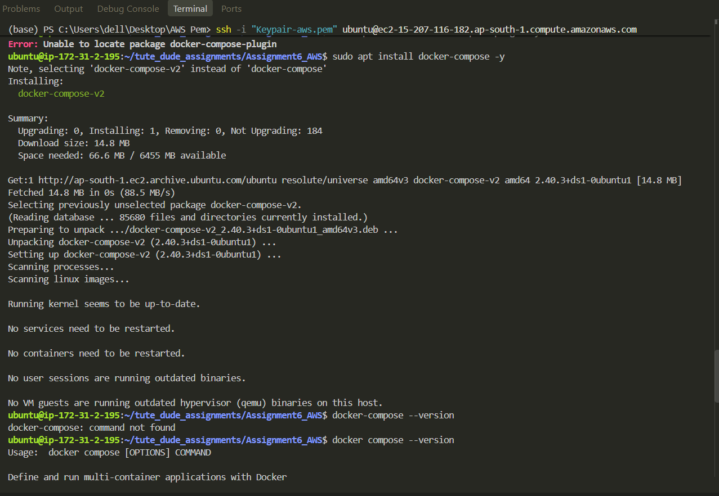

Did docker compose build
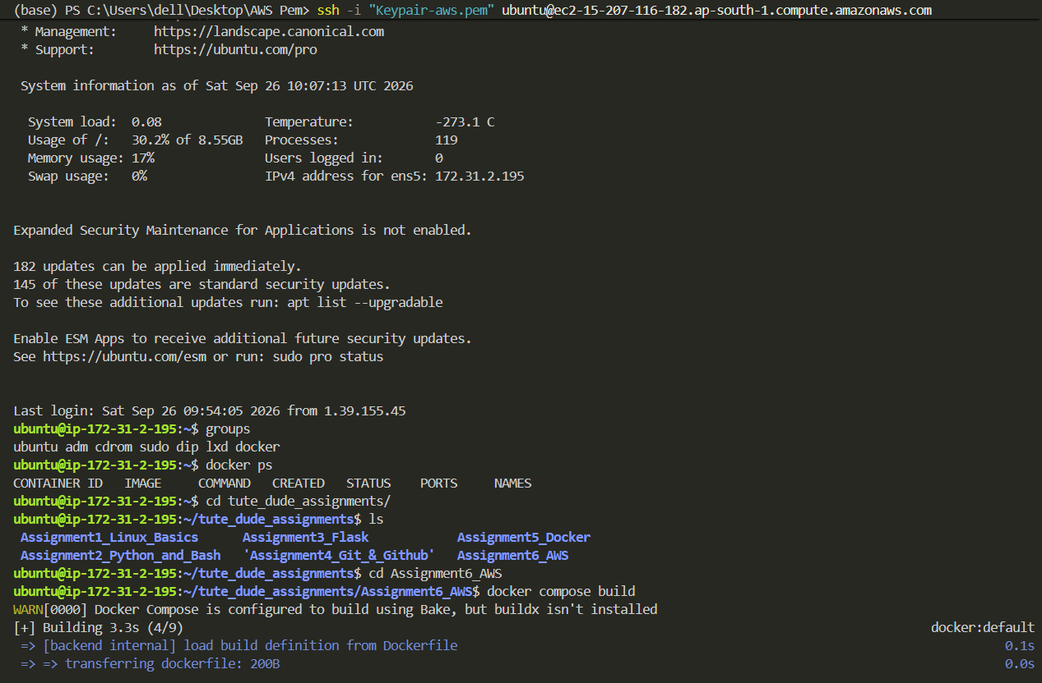
Then ran docker compose up
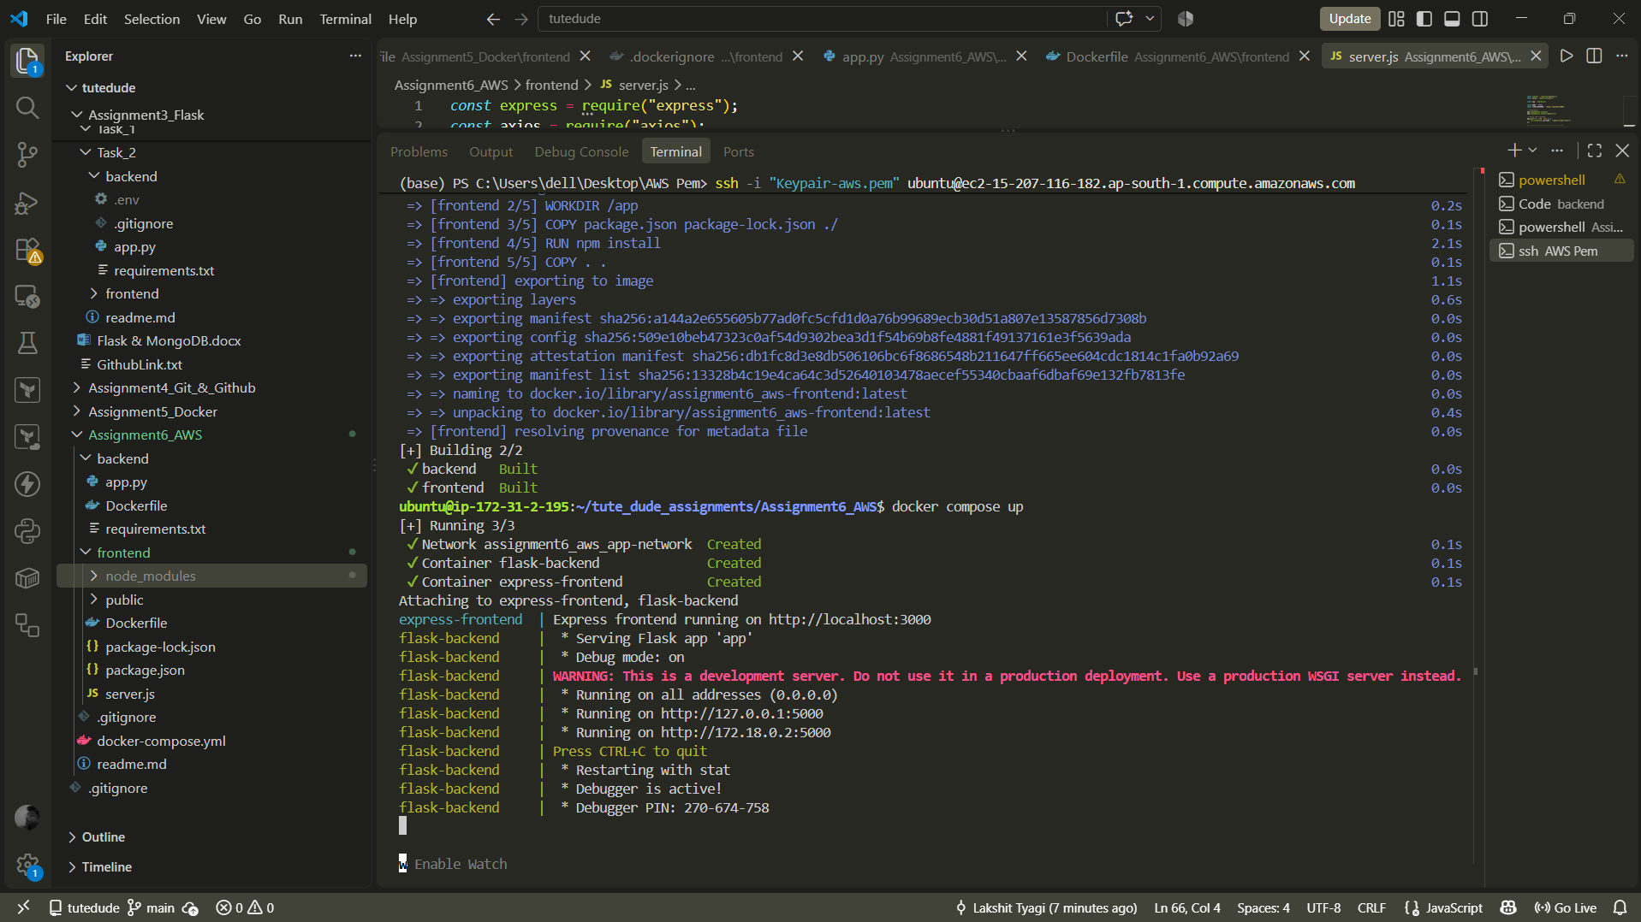

Added Inbound Rules to Access Port 3000 & 5000
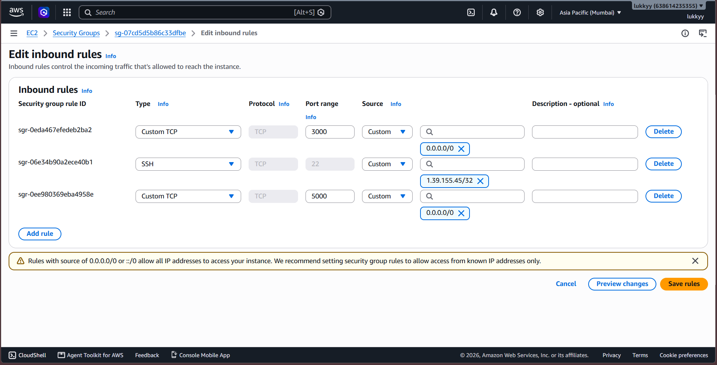

Using http, opened frontend port 3000, http://15.207.116.182:3000/
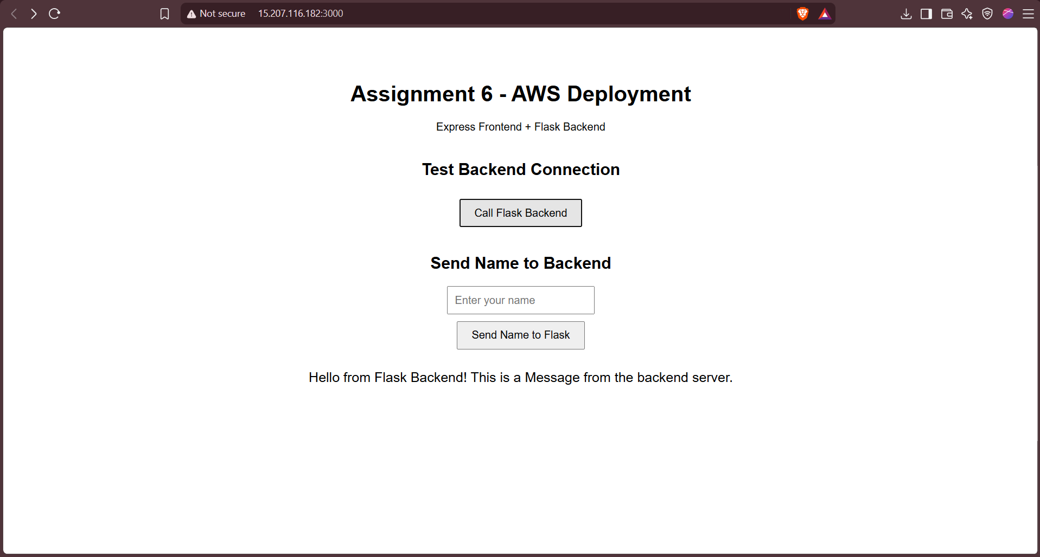
And backend port 5000, http://15.207.116.182:5000/
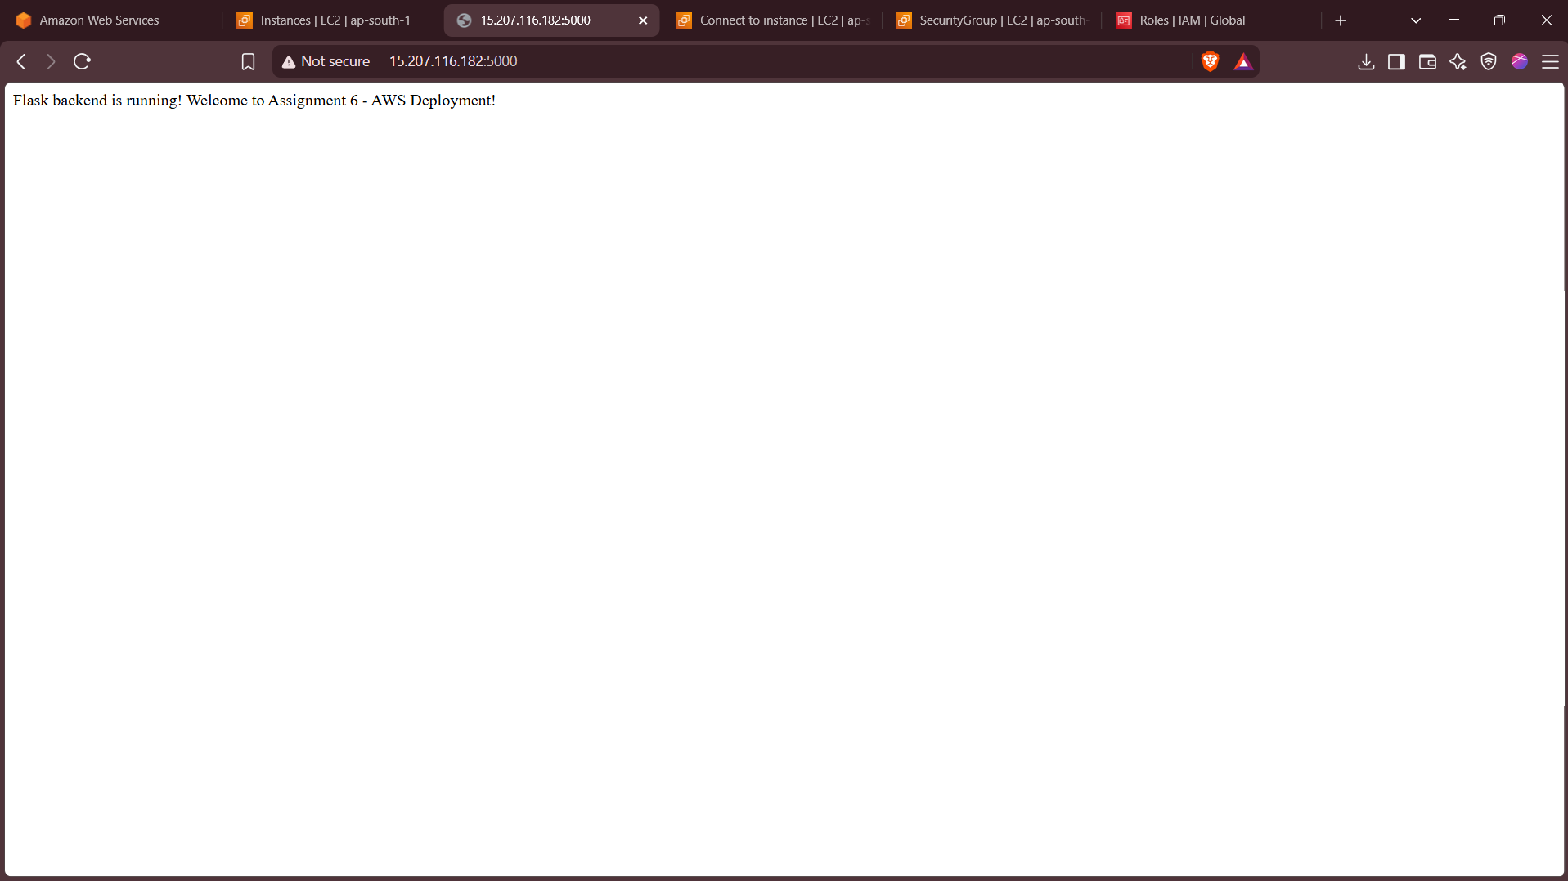

Task-2
For task-2 we dont need docker compose.

Editted the first ec2 name to be “1_Tutedude_AWS_Assignment_6” and created two ec2 instances

vpc/ami/security group/subnet & Os are same
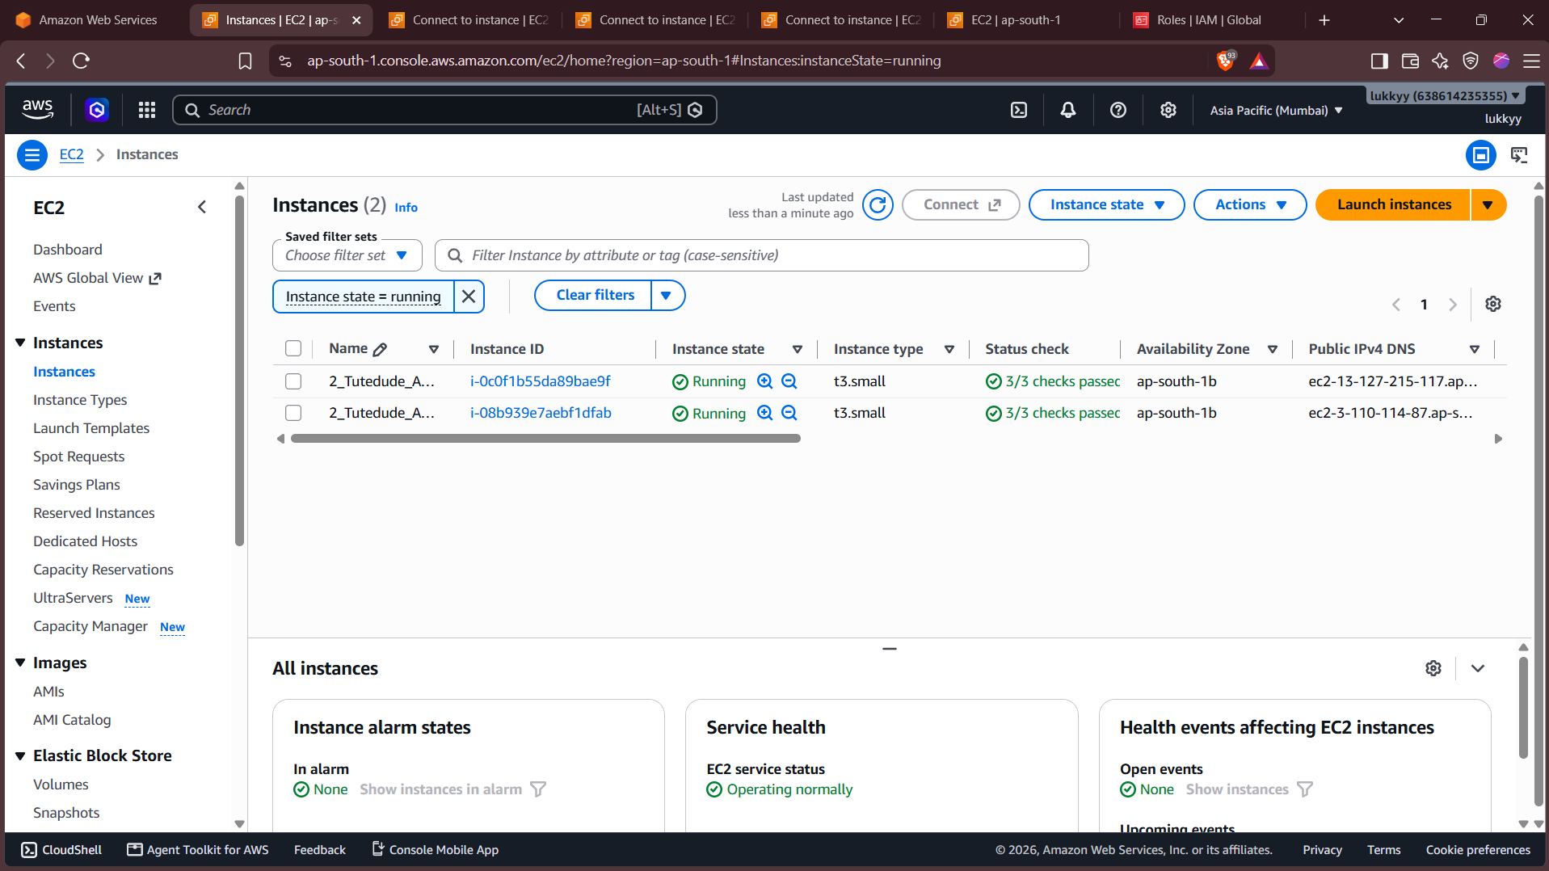
Did ssh in both ec2 instances
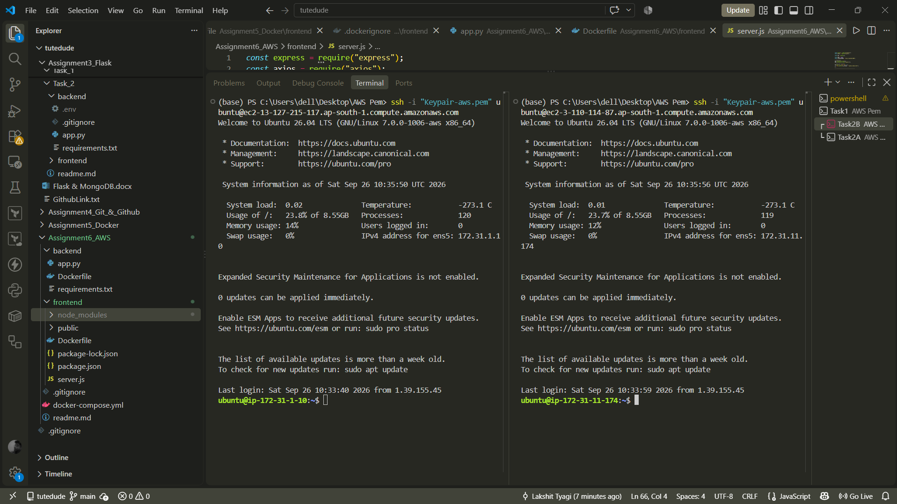
Clone repo in both ec2 and opened backend & frontend Directory respectively
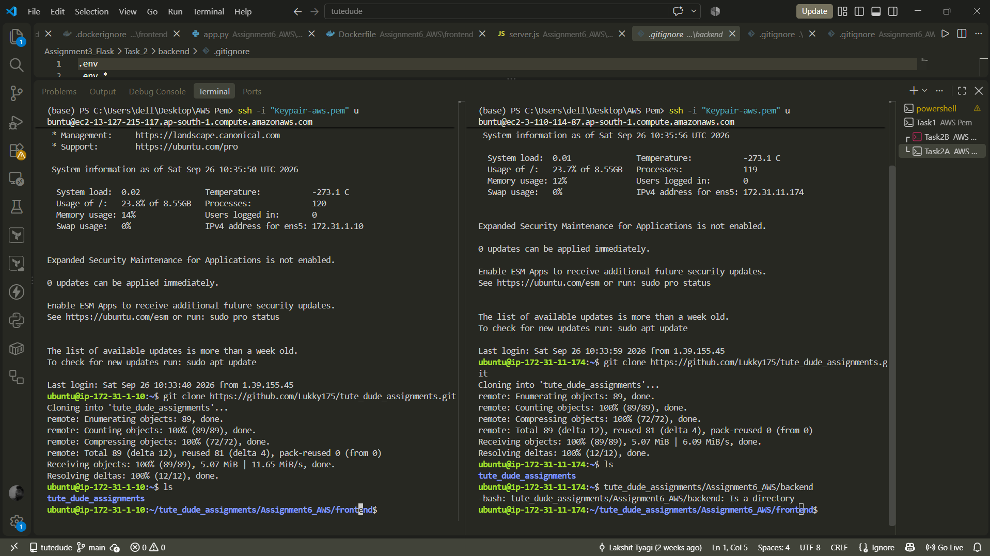

Ran Backend Docker Image on port 5000 http://3.110.114.87:5000/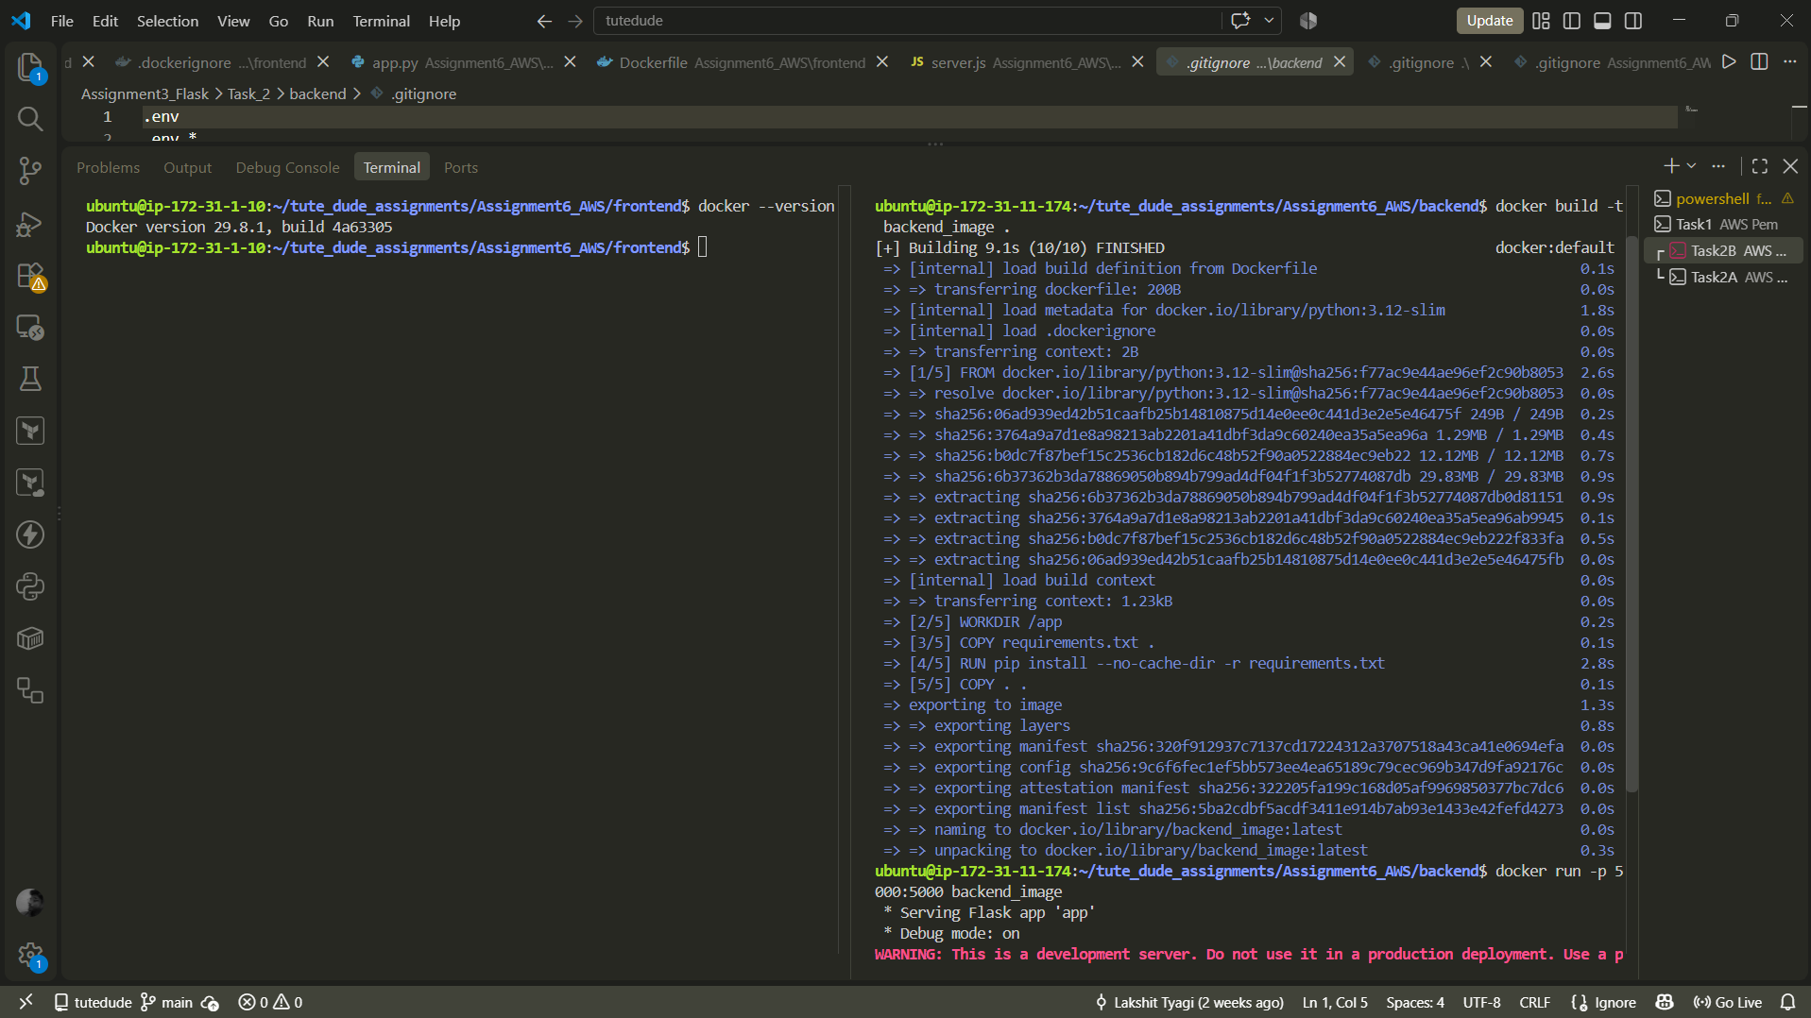

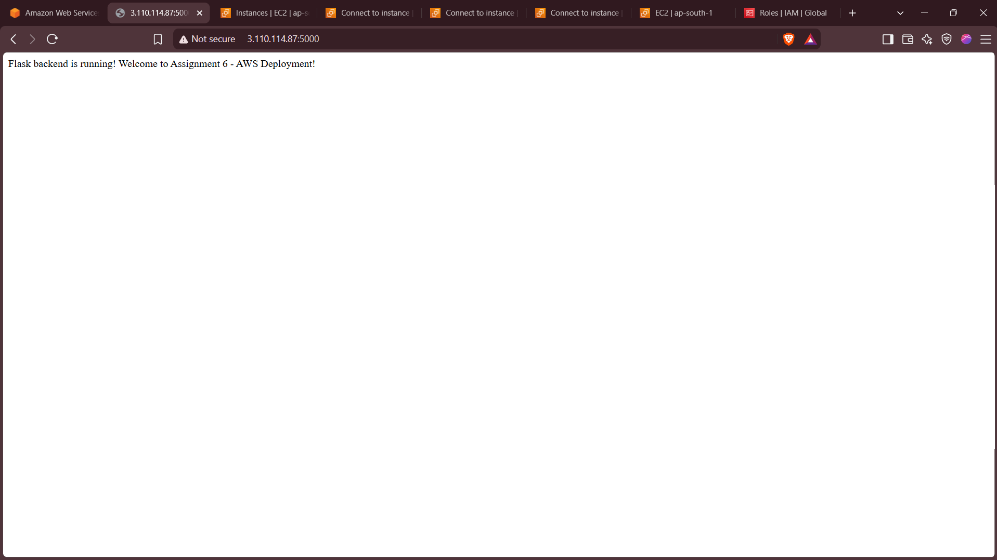

Install VIM
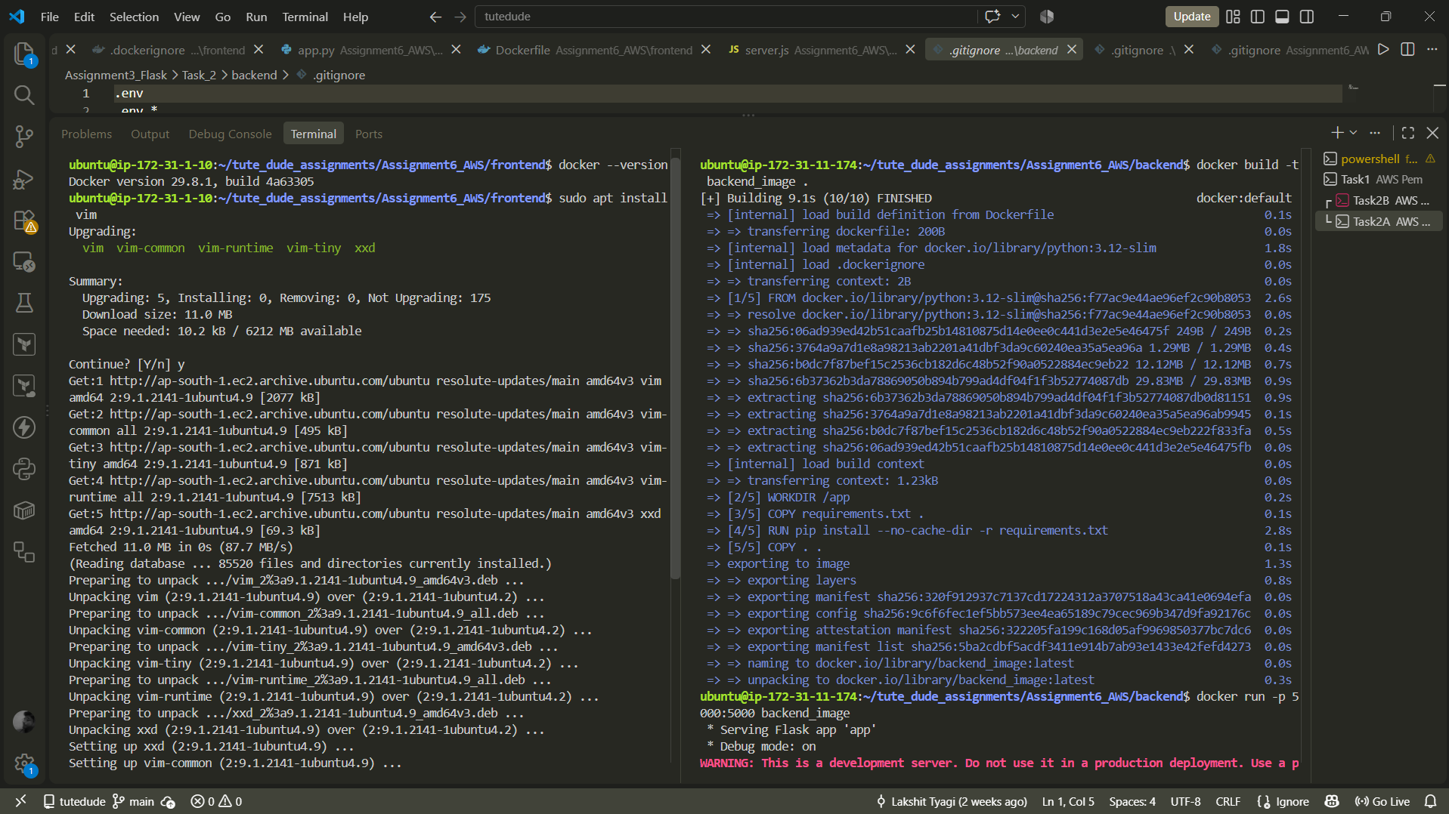

Copy the public ip and put in Frontend server.js using vim (left terminal in screenshot)
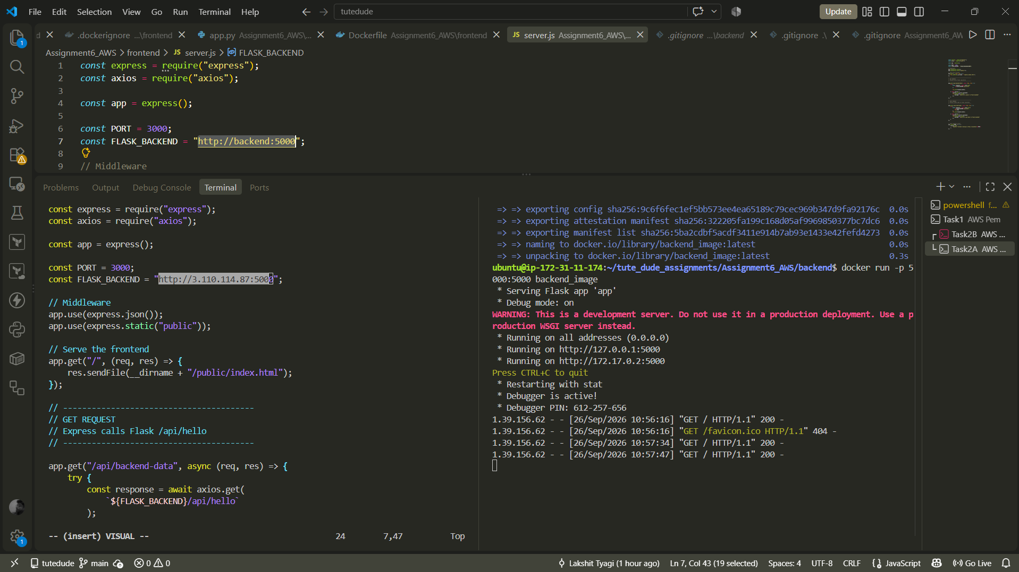

Built container (left terminal in screenshot)
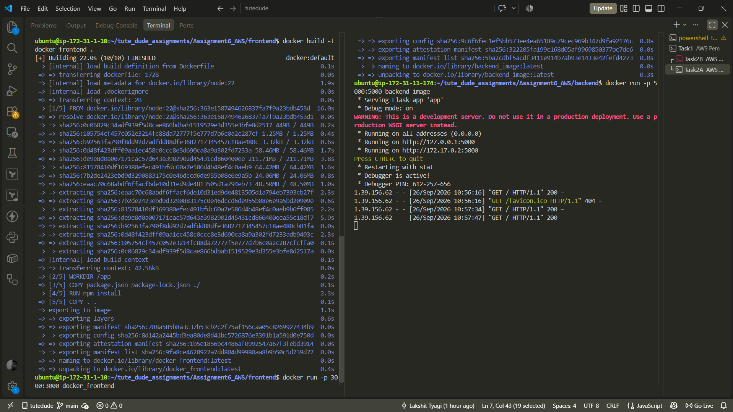

Opened Ec2 on port 3000 with public ip http://13.127.215.117:3000/
(Also tested backend connection it is working)
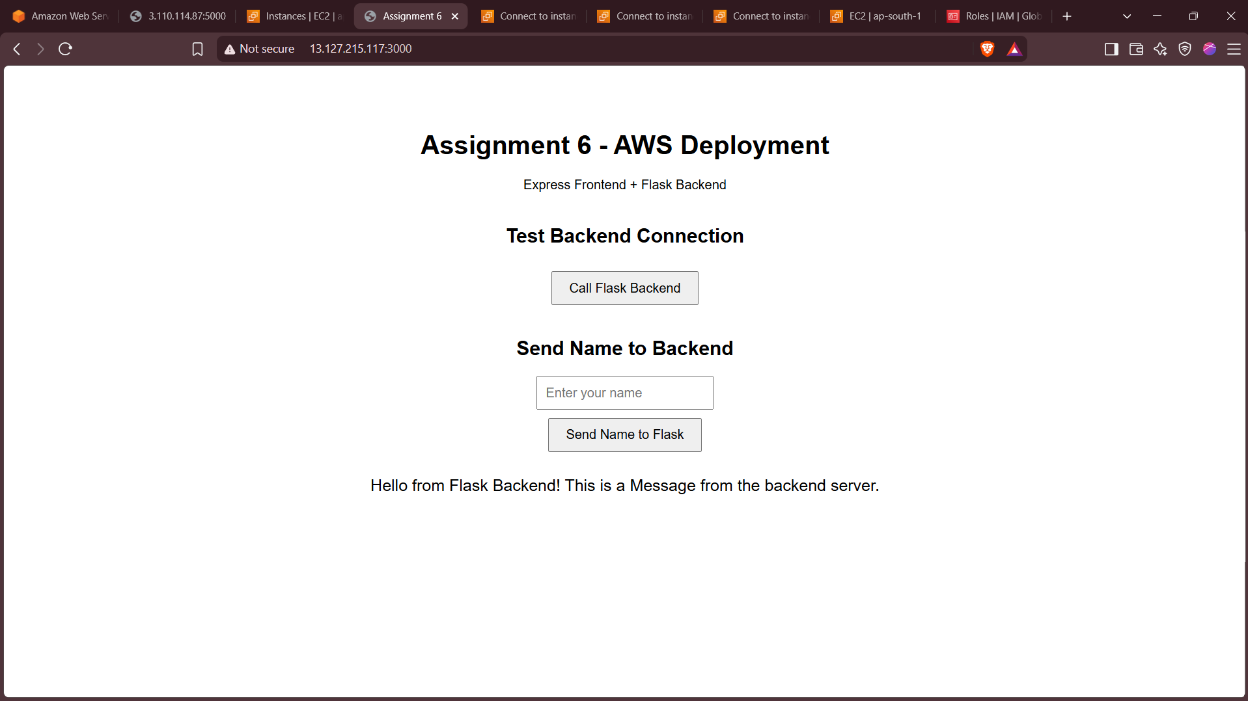
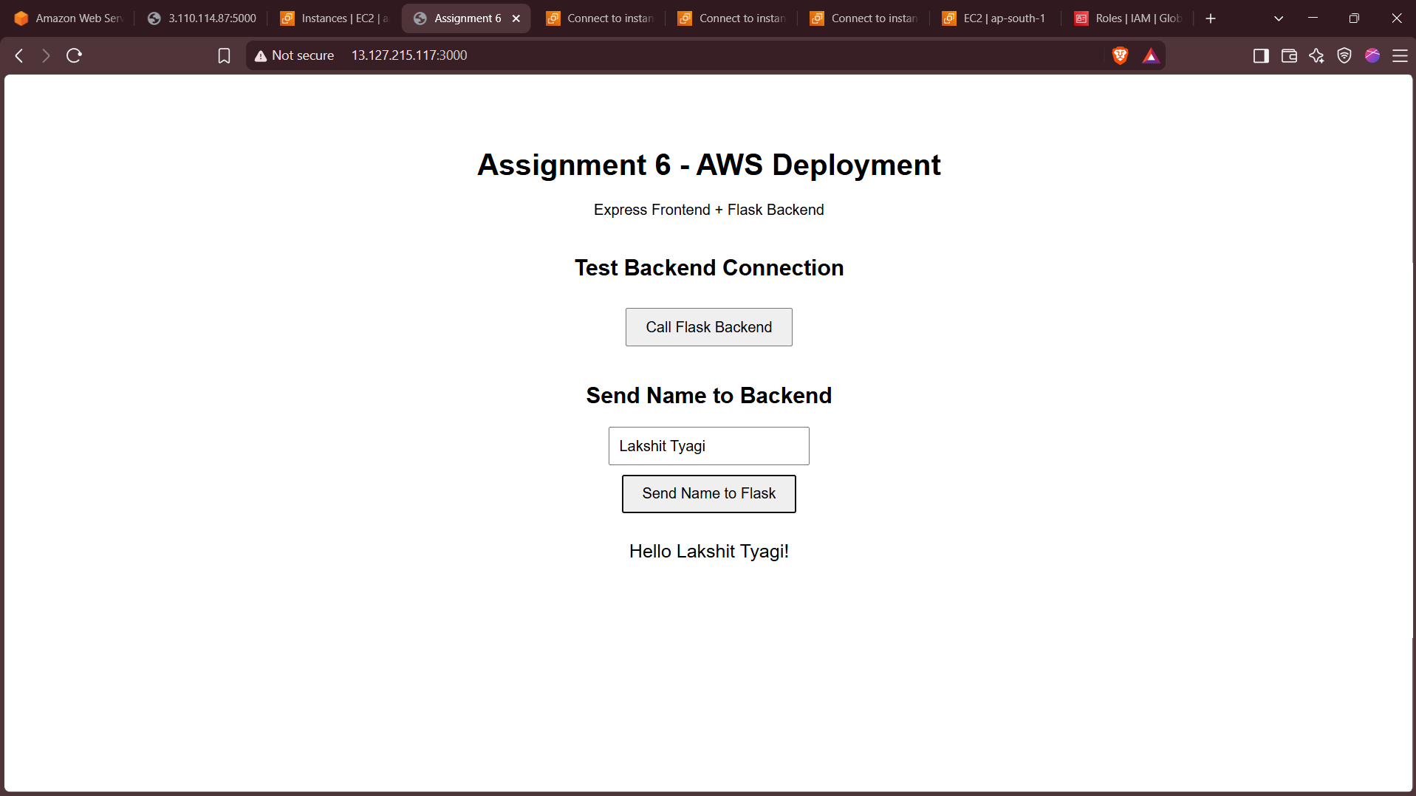

Task-3
Created 2 ECR Repository
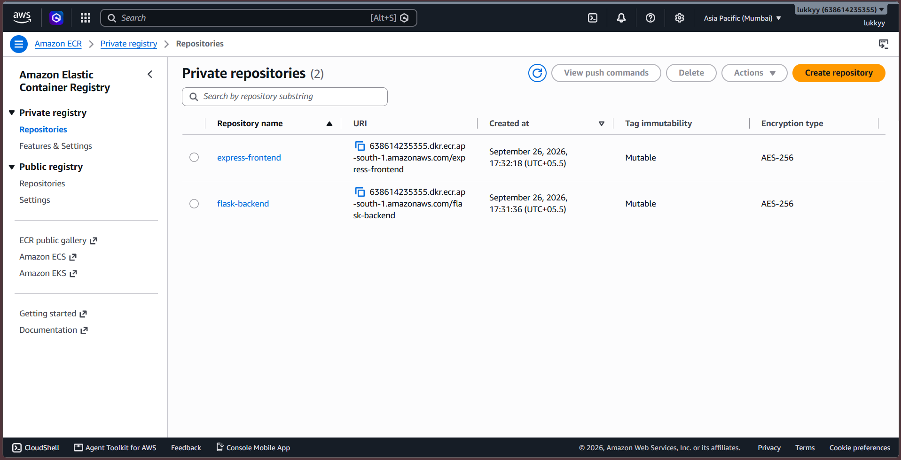

Pushed Docker images via CLI
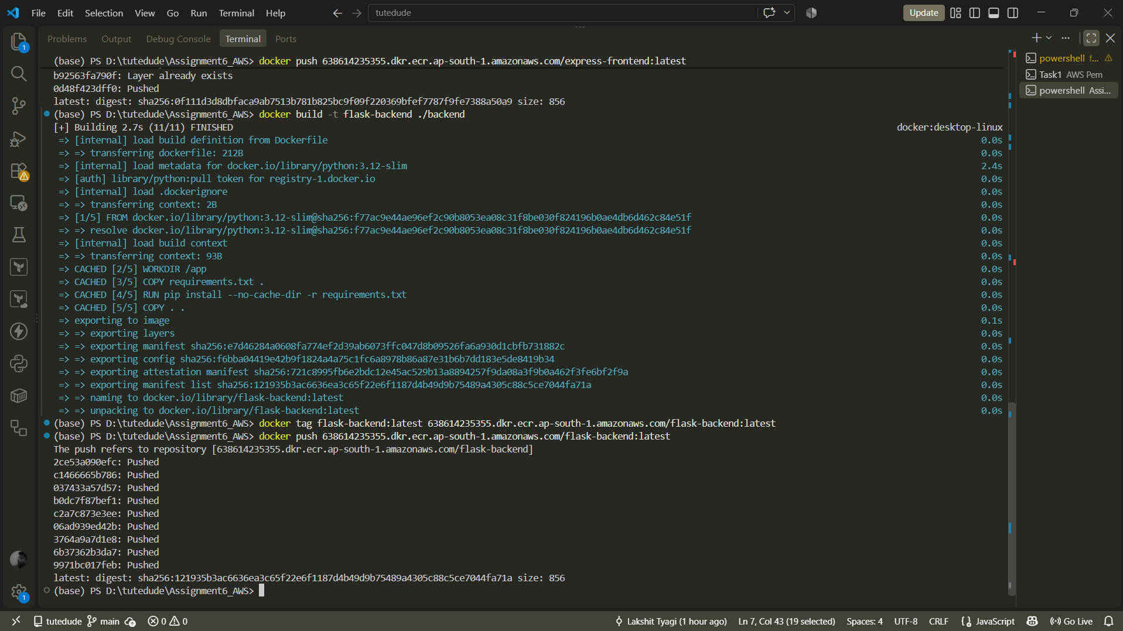

Commands in screenshot:

(base) PS D:\tutedude\Assignment6_AWS> aws --version
aws-cli/2.36.43 Python/3.14.6 Windows/11 exe/AMD64
(base) PS D:\tutedude\Assignment6_AWS> aws sts get-caller-identity
{
"UserId": "AIDAZJMC75DNSDWRUHQ4I",
"Account": "638614235355",
"Arn": "arn:aws:iam::638614235355:user/Lukky"
}

(base) PS D:\tutedude\Assignment6_AWS> aws ecr get-login-password --region ap-south-1 | docker login --username AWS --password-stdin 638614235355.dkr.ecr.ap-south-1.amazonaws.com
Login Succeeded
(base) PS D:\tutedude\Assignment6_AWS> docker build -t express-frontend ./frontend
[+] Building 3.4s (11/11) FINISHED docker:desktop-linux
=> [internal] load build definition from Dockerfile 0.0s
=> => transferring dockerfile: 184B 0.0s
=> [internal] load metadata for docker.io/library/node:22 3.0s
=> [auth] library/node:pull token for registry-1.docker.io 0.0s
=> [internal] load .dockerignore 0.0s
=> => transferring context: 2B 0.0s
=> [1/5] FROM docker.io/library/node:22@sha256:363e1587494626837fa7f9a23bdb453d13b0ff3c67c705c2805cfc69c2d2fad7 0.0s
=> => resolve docker.io/library/node:22@sha256:363e1587494626837fa7f9a23bdb453d13b0ff3c67c705c2805cfc69c2d2fad7 0.0s
=> [internal] load build context 0.1s
=> => transferring context: 55.75kB 0.1s
=> CACHED [2/5] WORKDIR /app 0.0s
=> CACHED [3/5] COPY package.json package-lock.json ./ 0.0s
=> CACHED [4/5] RUN npm install 0.0s
=> CACHED [5/5] COPY . . 0.0s
=> exporting to image 0.1s
=> => exporting layers 0.0s
=> => exporting manifest sha256:f14d5938ee10066eed21b4ae73b0aba275b15c7afd6ea1bd17170a3b4972fb64 0.0s
=> => exporting config sha256:dc4543db6e037cf1fb6bc0c7a367328d47a9ba7e7b00f3089354d117aca9c8b1 0.0s
=> => exporting attestation manifest sha256:5873a565f5a248d2e5e97720f7c1d74ee879434971bc93169d1e2459de1e7a0a 0.0s
=> => exporting manifest list sha256:0f111d3d8dbfaca9ab7513b781b825bc9f09f220369bfef7787f9fe7388a50a9 0.0s
=> => naming to docker.io/library/express-frontend:latest 0.0s
=> => unpacking to docker.io/library/express-frontend:latest 0.0s
(base) PS D:\tutedude\Assignment6_AWS> docker tag express-frontend:latest 638614235355.dkr.ecr.ap-south-1.amazonaws.com/express-frontend:latest
(base) PS D:\tutedude\Assignment6_AWS> docker push 638614235355.dkr.ecr.ap-south-1.amazonaws.com/express-frontend:latest
The push refers to repository [638614235355.dkr.ecr.ap-south-1.amazonaws.com/express-frontend]
0c06829c34ad: Pushed
0d48f423dff0: Pushing [==========> ] 11.89MB/58.46MB
eaac70c68abd: Pushing [========> ] 8.225MB/48.5MB
414ff51e0544: Pushed
808049a1228f: Pushed
321f73e9271f: Pushed
56ed00ebfee3: Pushed
b92563fa790f: Pushed
7b2de2423ebd: Pushing [=========> ] 4.358MB/24.06MB
105754cf457c: Pushed
de9e8d0a0071: Pushing [==> ] 11.53MB/211.7MB
ce98ce33ca74: Pushed
81578410df16: Pushing [======> ] 8.585MB/64.42MB
failed to copy: failed to do request: Put "https://638614235355.dkr.ecr.ap-south-1.amazonaws.com/v2/express-frontend/blobs/uploads/baabfc07-1bb3-340e-8dd1-09c8db06670c?digest=sha256%3Aeaac70c68abdf6ffacf6de10d31ed9de4813505d1a794eb7393cb27fceb624a6": write tcp 192.168.65.3:34028->192.168.65.1:3128: use of closed network connection
(base) PS D:\tutedude\Assignment6_AWS> docker push 638614235355.dkr.ecr.ap-south-1.amazonaws.com/express-frontend:latest
The push refers to repository [638614235355.dkr.ecr.ap-south-1.amazonaws.com/express-frontend]
808049a1228f: Layer already exists
ce98ce33ca74: Layer already exists
81578410df16: Pushed
414ff51e0544: Layer already exists
105754cf457c: Layer already exists
56ed00ebfee3: Layer already exists
0c06829c34ad: Layer already exists
7b2de2423ebd: Pushed
de9e8d0a0071: Pushed
eaac70c68abd: Pushed
321f73e9271f: Already exists
b92563fa790f: Layer already exists
0d48f423dff0: Pushed
latest: digest: sha256:0f111d3d8dbfaca9ab7513b781b825bc9f09f220369bfef7787f9fe7388a50a9 size: 856
(base) PS D:\tutedude\Assignment6_AWS> docker build -t flask-backend ./backend
[+] Building 2.7s (11/11) FINISHED docker:desktop-linux
=> [internal] load build definition from Dockerfile 0.0s
=> => transferring dockerfile: 212B 0.0s
=> [internal] load metadata for docker.io/library/python:3.12-slim 2.4s
=> [auth] library/python:pull token for registry-1.docker.io 0.0s
=> [internal] load .dockerignore 0.0s
=> => transferring context: 2B 0.0s
=> [1/5] FROM docker.io/library/python:3.12-slim@sha256:f77ac9e44ae96ef2c90b8053ea08c31f8be030f824196b0ae4db6d462c84e51f 0.0s
=> => resolve docker.io/library/python:3.12-slim@sha256:f77ac9e44ae96ef2c90b8053ea08c31f8be030f824196b0ae4db6d462c84e51f 0.0s
=> [internal] load build context 0.0s
=> => transferring context: 93B 0.0s
=> CACHED [2/5] WORKDIR /app 0.0s
=> CACHED [3/5] COPY requirements.txt . 0.0s
=> CACHED [4/5] RUN pip install --no-cache-dir -r requirements.txt 0.0s
=> CACHED [5/5] COPY . . 0.0s
=> exporting to image 0.1s
=> => exporting layers 0.0s
=> => exporting manifest sha256:e7d46284a0608fa774ef2d39ab6073ffc047d8b09526fa6a930d1cbfb731882c 0.0s
=> => exporting config sha256:f6bba04419e42b9f1824a4a75c1fc6a8978b86a87e31b6b7dd183e5de8419b34 0.0s
=> => exporting attestation manifest sha256:721c8995fb6e2bdc12e45ac529b13a8894257f9da08a3f9b0a462f3fe6bf2f9a 0.0s
=> => exporting manifest list sha256:121935b3ac6636ea3c65f22e6f1187d4b49d9b75489a4305c88c5ce7044fa71a 0.0s
=> => naming to docker.io/library/flask-backend:latest 0.0s
=> => unpacking to docker.io/library/flask-backend:latest 0.0s
(base) PS D:\tutedude\Assignment6_AWS> docker tag flask-backend:latest 638614235355.dkr.ecr.ap-south-1.amazonaws.com/flask-backend:latest
(base) PS D:\tutedude\Assignment6_AWS> docker push 638614235355.dkr.ecr.ap-south-1.amazonaws.com/flask-backend:latest
The push refers to repository [638614235355.dkr.ecr.ap-south-1.amazonaws.com/flask-backend]
2ce53a090efc: Pushed
c1466665b786: Pushed
037433a57d57: Pushed
b0dc7f87bef1: Pushed
c2a7c873e3ee: Pushed
06ad939ed42b: Pushed
3764a9a7d1e8: Pushed
6b37362b3da7: Pushed
9971bc017feb: Pushed
latest: digest: sha256:121935b3ac6636ea3c65f22e6f1187d4b49d9b75489a4305c88c5ce7044fa71a size: 856
(base) PS D:\tutedude\Assignment6_AWS>

Created a ECS Cluster
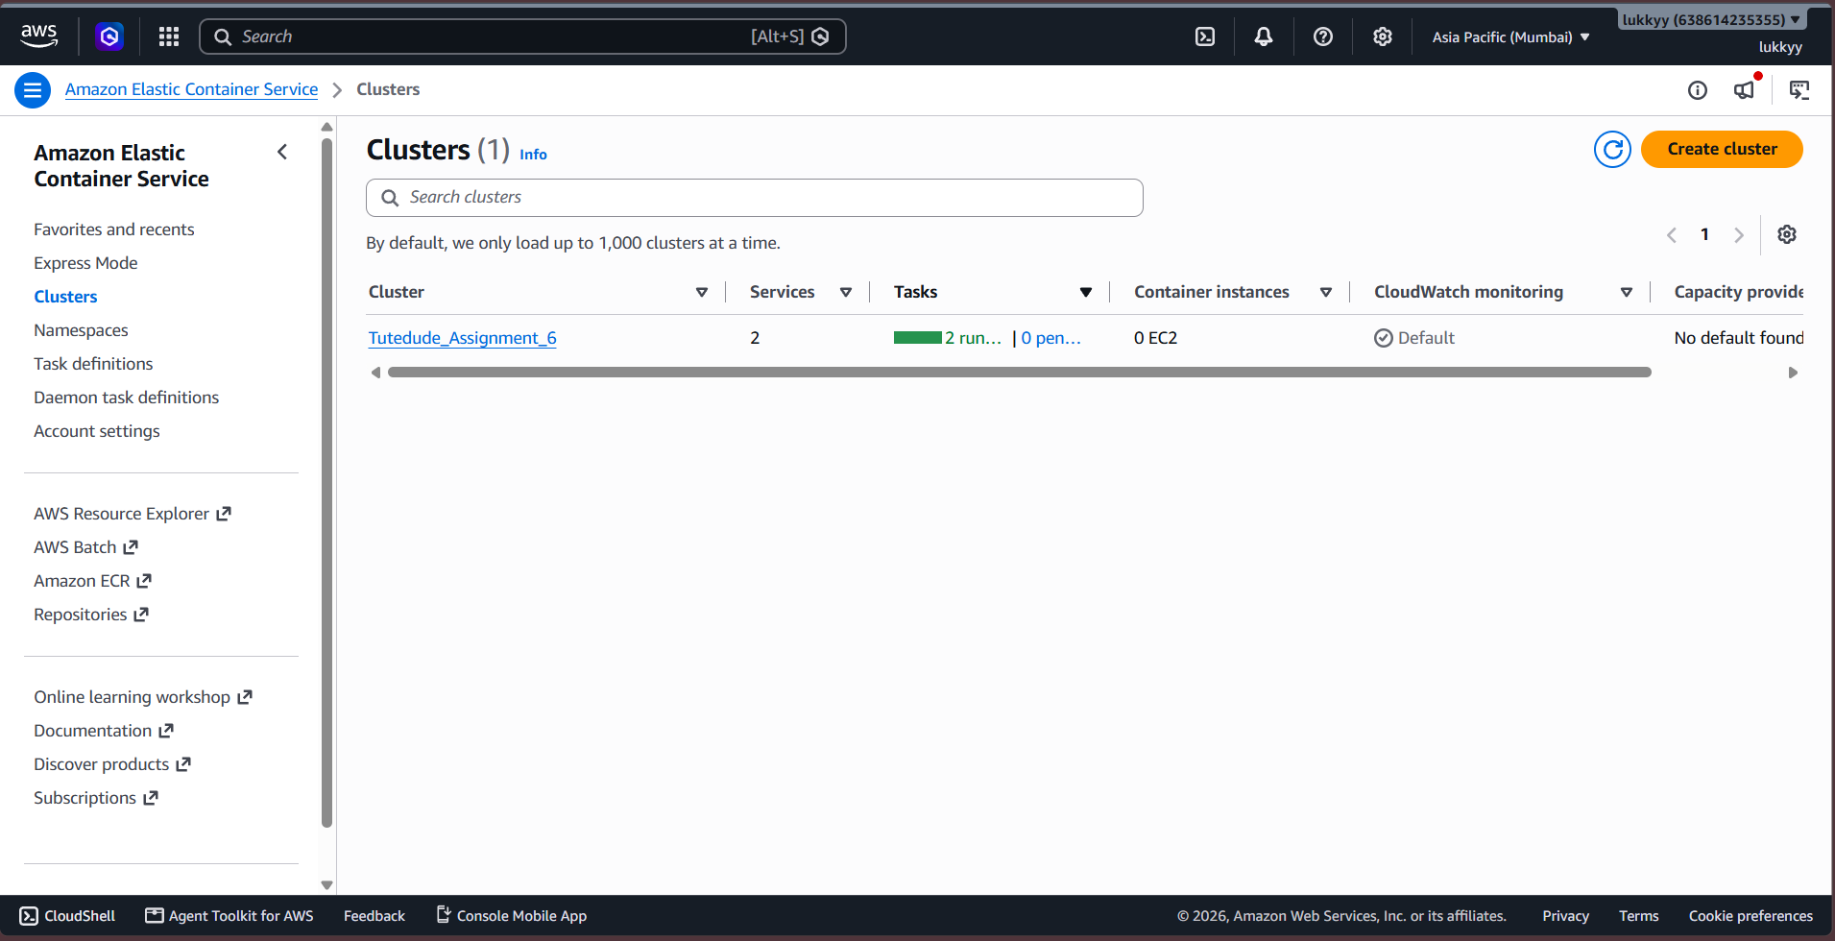

Created 2 Task Definitions
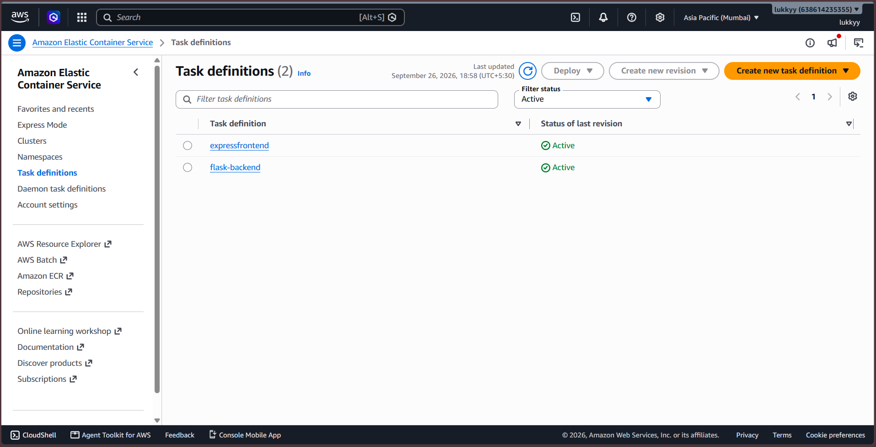

Created 2 Services for each container
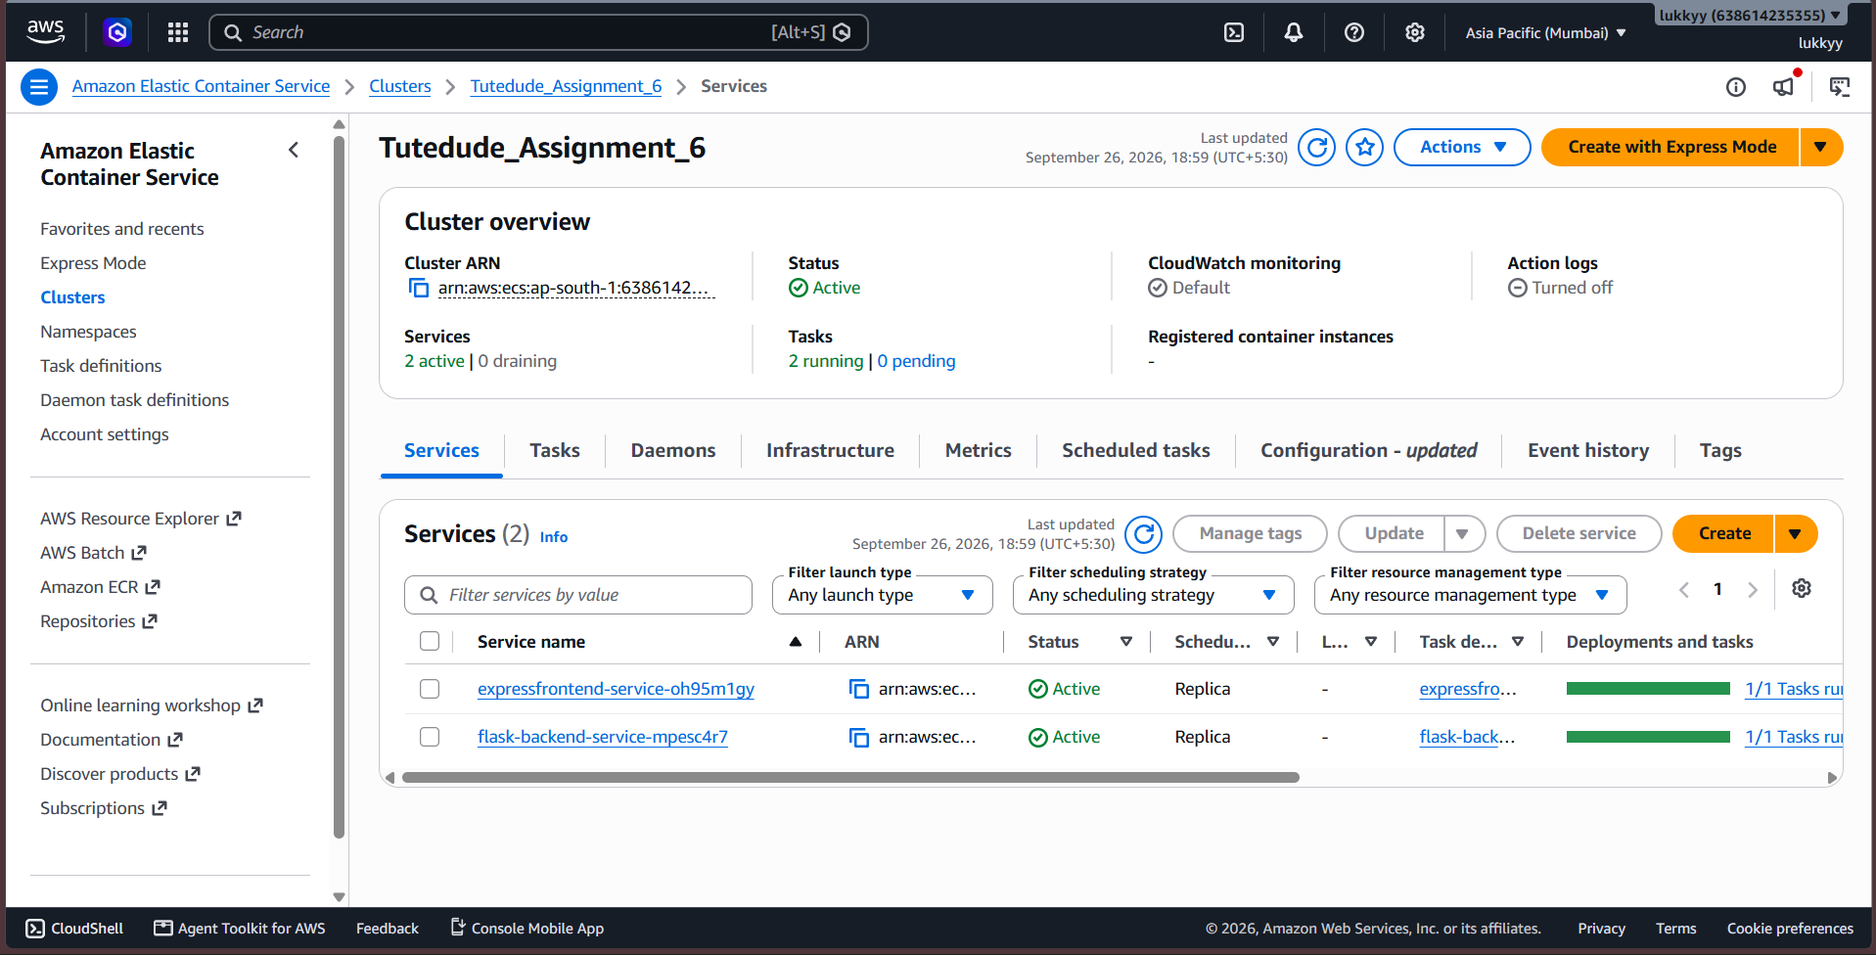

Frontend port 3000 Ip http://65.0.138.36:3000/
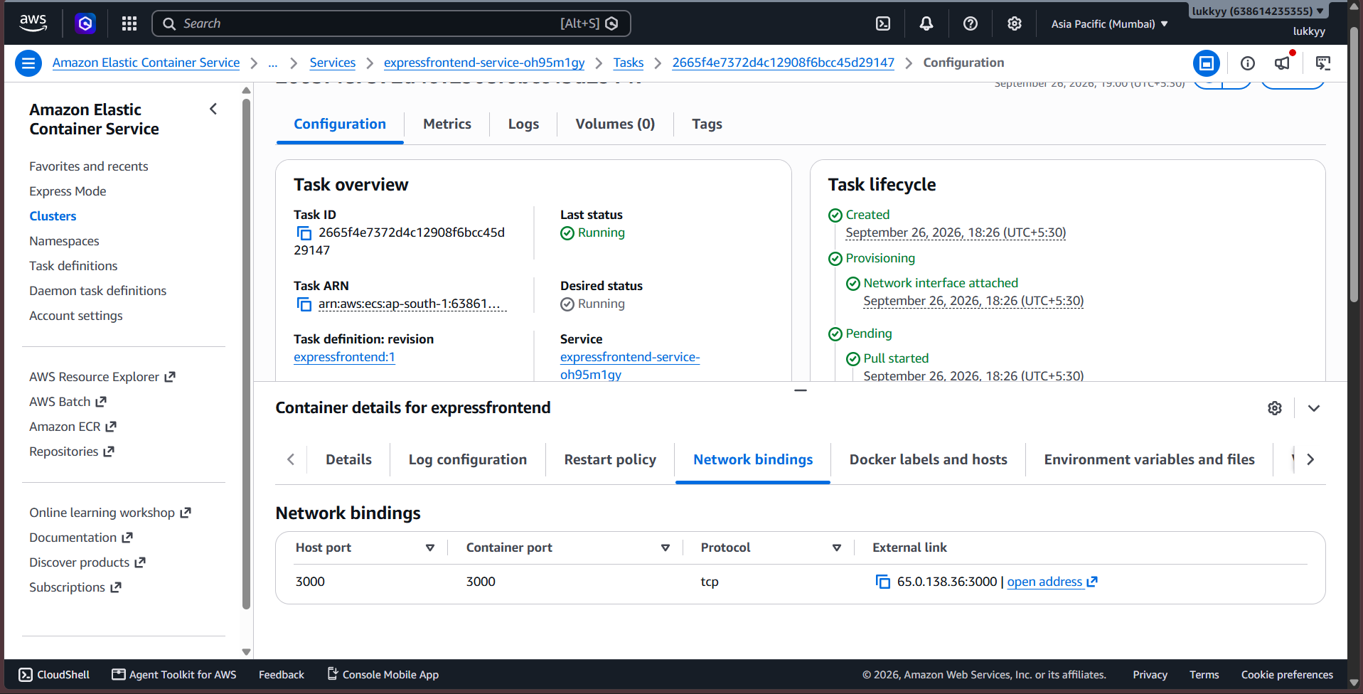
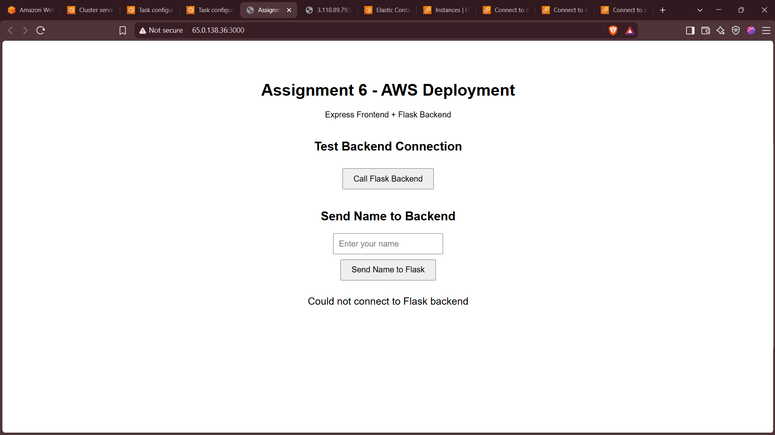
Backend port 5000 ip http://3.110.89.79:5000/
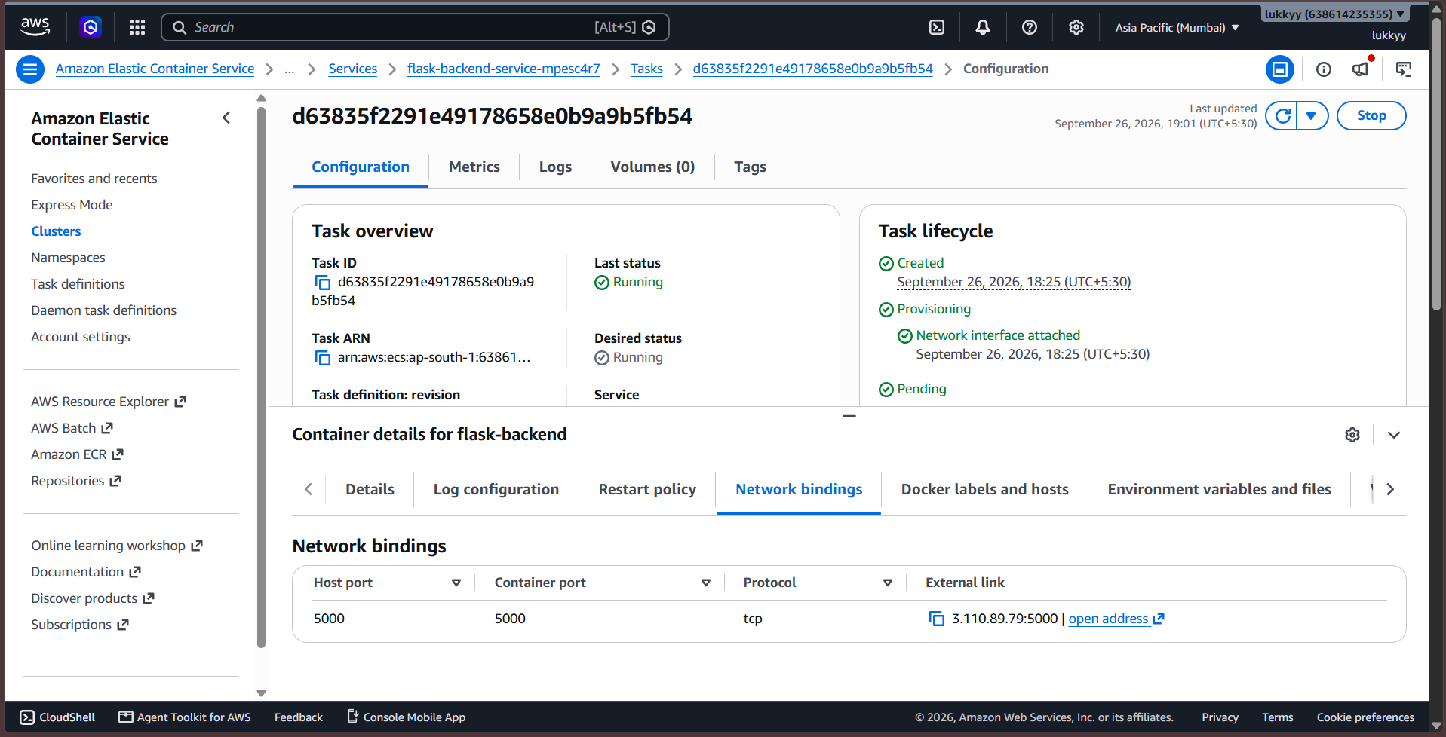
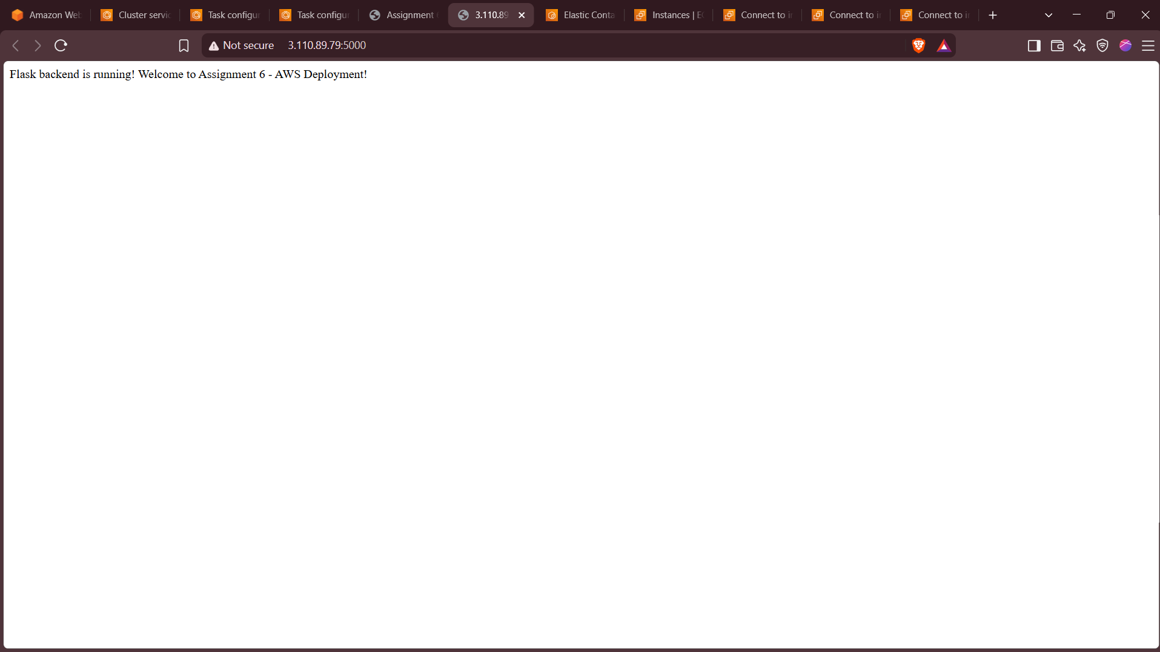

Now Frontend and Backend aren’t connected right now this is because we need to enter the backend ip address in frontend server.js, so we will need to rebuild and repush docker image.
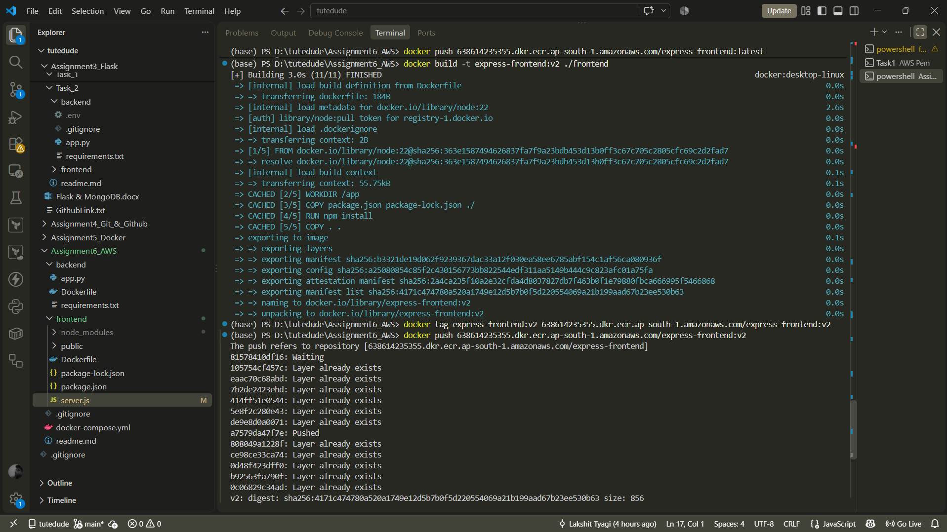

In Task Definitions Created a new Revision
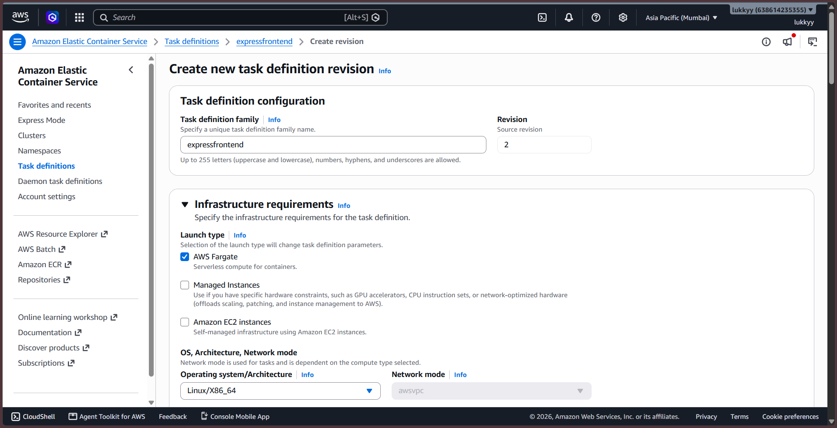
Update Service
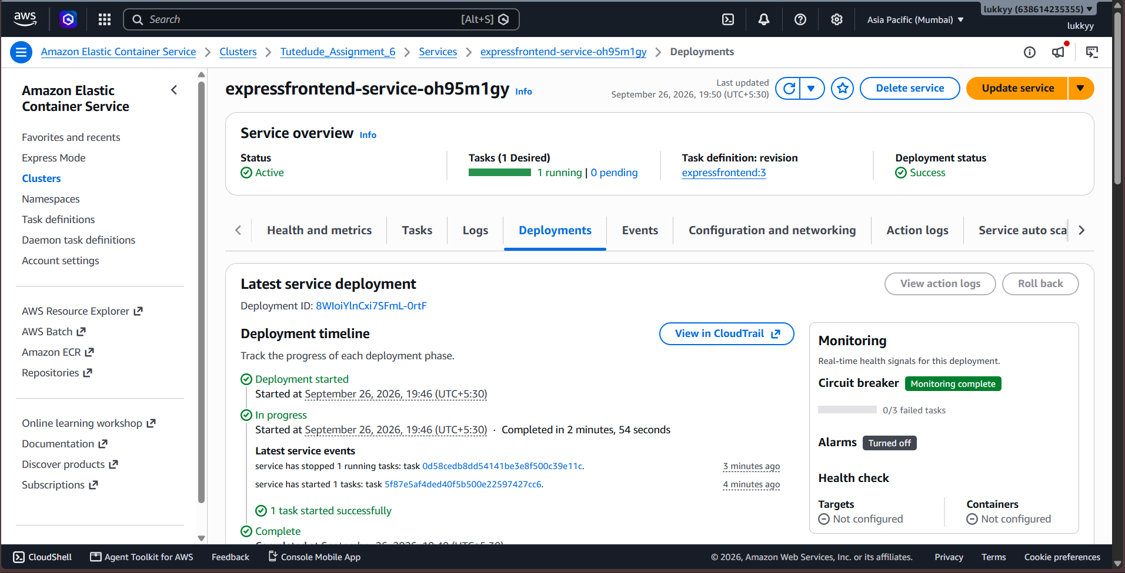

Now Frontend Container is Running on http://3.110.142.24:3000/ and backend container http://3.110.89.79:5000/ and they are connected

Backend
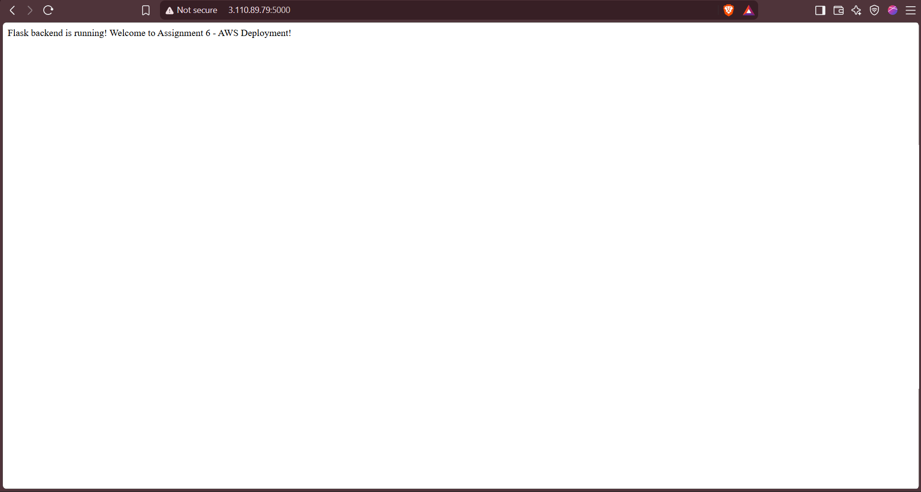
Frontend
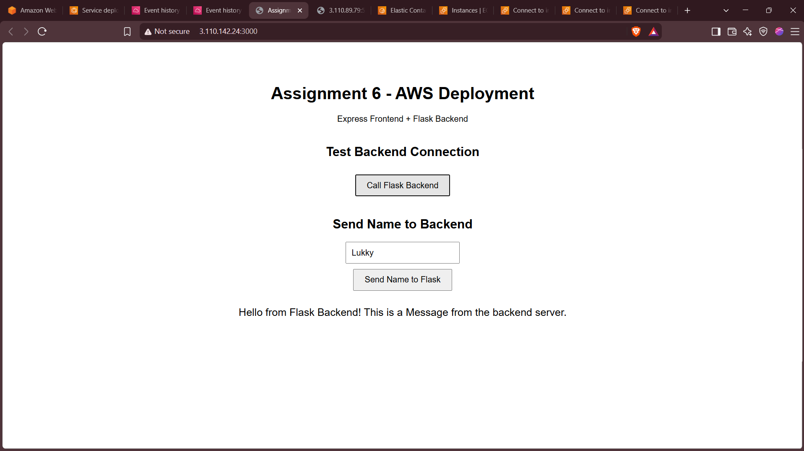

Finally Stopped all instances and ECS as per instructions to save cost, and added all of the required screenshots. Thus all of the Tasks are Completed as per the Requirements.

